IB School Code: 052067

TONGWEN SCHOOL
(JIAXING)




CREATIVITY, ACTIVITY AND SERVICE

STUDENT HANDBOOK

Date: March 2017 (Updated 2022)

TABLE OF CONTENTS

A BRIEF OVERVIEW: WHAT IS CAS?...........................................................................................3

THE RESPONSIBILITIES OF A CAS STUDENT...............................................................................4

CAS SUPERVISOR.......................................................................................................................5

CAS LEARNING OUTCOMES.......................................................................................................7

CAS LEARNING OUTCOME DESCRIPTORS..................................................................................8

CAS STAGES............................................................................................................................ 10

CAS STRANDS......................................................................................................................... 11

CAS PROJECT.......................................................................................................................... 15

CAS PROJECT FORMATION FORM.......................................................................................... 17

THE CAS PORTFOLIO............................................................................................................... 19

REFLECTIONS.......................................................................................................................... 20

A CHECKLIST: GETTING STARTED........................................................................................... 22

DP TIMELINES AND DEADLINES.............................................................................................. 23

GUIDELINES TO CAS EXPERIENCES......................................................................................... 24

MANAGEBAC TUTORIAL......................................................................................................... 25

A FINAL WORD....................................................................................................................... 33

A BRIEF OVERVIEW: WHAT IS CAS?

The International Baccalaureate aims to develop internationally minded people who are responsible members of local, national and global communities.



CAS is designed for students to demonstrate attributes of the IB learner profile in real life situations and is at the heart of the Diploma Programme.

It is a collection of enjoyable and challenging experiences determined by you.
These experiences allow you to explore your interests, expand your passions and develop into a well-rounded member of society.

CAS is made up of three strands:

Creativity – exploring and extending ideas leading to an original or interpretive product of performance.

Activity – physical exertion contributing to a healthy lifestyle.

Service – collaborative and reciprocal engagement with the community in response
to an authentic need.

The CAS programme begins at the start of the Diploma Programme and continues regularly, ideally on a weekly basis, for at least 18 months with a reasonable balance between creativity, activity and service.

THE RESPONSIBILITIES OF A CAS STUDENT

THE APPROACH

- Be proactive. Don’t sit around waiting for something happen - make it happen!

- Develop a clear understanding of CAS expectations and the purpose of CAS.

- Refer to the IB learner profile and the IB mission statement.

- Determine personal goals.

- Discuss plans for CAS experiences with the CAS coordinator and/or CAS adviser.

- Become more aware of personal interests, skills and talents and base your experiences around them.

- Understand the process of reflection.

- Ensure a suitable balance between creativity, activity and service.

THE ACTION

- Maintain an up-to-date CAS portfolio with detailed records and meaningful reflections of experiences.

Include evidence of your achievement of the seven CAS learning outcomes.

- Understand and apply the CAS stages where appropriate.

- Take part in a variety of experiences, some of which are self-initiated.

- Take part in at least one CAS project.

- Behave appropriately and ethically in choices and behaviours.

- Demonstrate accomplishments within the CAS programme.

- Communicate with the CAS coordinator and/or CAS adviser and/or CAS supervisor in formal and informal meetings.

A minimum of three formal interviews with the CAS coordinator.

- Ask questions along the way if you need assistance or clarification.

- Meet all deadlines!
CAS SUPERVISOR

CAS supervisors are adults that assist, offer guidance and oversees the students’ CAS experiences when needed. A supervisor may not be necessary if a student is able to undertake a CAS experience without assistance or supervision.

WHO can be CAS supervisor?
- Teachers
Example: PE teacher to supervise a student-led basketball ASA club.
- Non-teaching members of the school or wider community
Example: School IT staff to supervise a student-led IT workshop to freshmen.
Organization staff to supervise your volunteer service for an NGO.
- Adult with the skills and/or knowledge of the CAS experience undertaken by the student.
Example: Flute teacher to supervise when you take weekly lessons for 18 months.
Skiing instructor to supervise when you take a beginner level skiing lesson.

WHO cannot be CAS supervisor?
- Family member
- Fellow student
- Peers

A CAS supervisor:
- is familiar with elements of the CAS program as applicable.
- is responsible for student’s safety and risk management procedures.
- is responsible for the orderly conduct of the CAS experience under supervision.
- provides students with guidance, support and feedback on CAS experience/project.
- encourage and checks student’s CAS reflections at a certain period of time.
- provide feedback on student’s attendance, participation, engagement through supervisor review on Managebac.

Additional notes:
- For each experience you plan to undertake, you should communicate with the CAS coordinator, who must agree that it is a valid experience before you go ahead. If you are not sure whether you need a CAS supervisor or who can be your CAS supervisor, check with your CAS coordinator.

- Not every CAS experience must be supervised if the CAS coordinator determines the experience is safe, and the student is trusted to account truthfully on his/her attendance and participation.

- Once you have determined who is appropriate to be the CAS supervisor for your single CAS experience/project, it is suggested that you find a suitable time to explain to him/her what CAS is (if applicable) and what you are trying to achieve. After you get the potential CAS supervisor’s permission, obtain his/her email address so as to fill out “New Experience” page on Managebac. CAS supervisor will provide feedback through link included in an email sent by Managebac.

- In TWS, when a group of DP students start a student-led ASA (after school activity) as their CAS project, they can raise a fund pool to financially support the activities they organize. One student member (or take turns) should keep an accurate record of the money through a balance sheet and a collection of the receipts and/or invoices. The CAS supervisor should be an external auditor to check on the accuracy and correctness of the above documents at least once a month. If there’s money left at the end of the ASA, the money should be returned to the participants, and the CAS supervisor should check whether the refund is in place so as to make sure this CAS experience/project is unpaid and voluntary.

CAS LEARNING OUTCOMES

LEARNING OUTCOME | DESCRIPTOR
1 | Identify own strengths and develop areas for growth.
 | See yourself as an individual with various responsibilities and skills, some of which are more developed than others.
2 | Demonstrate that challenges have been undertaken, developing new skills in the process.
 | A new challenge may be an unfamiliar experience or an extension of an existing one. The newly acquired or developed skills may be shown through experiences you have not previously undertaken or through increased expertise in an established area.
3 | Demonstrate how to initiate and plan a CAS experience.
 | Articulate the stage from conceiving an idea to executing a plan for a CAS experience or series of CAS experiences. This may be accomplished in collaboration with other participants. Show your knowledge and awareness by building on a previous experience, or by launching a new idea or process.
4 | Show commitment to and perseverance in CAS experiences.
 | Demonstrate regular involvement and active engagement in CAS.
5 | Demonstrate the skills and recognize the benefits of working collaboratively.
 | Identify, demonstrate and critically discuss the benefits and challenges of collaboration gained through CAS experiences.
6 | Demonstrate engagement with issues of global significance.
 | Identify and demonstrate your understanding of global issues, make responsible decisions and take appropriate action in response to the issues locally, nationally or internationally.
7 | Recognize and consider the ethics of choices and actions.
 | Show awareness of the consequences of choices and actions in planning and carrying out CAS experiences.

CAS LEARNING OUTCOME DESCRIPTORS

Please note, the following descriptors only serve as suggestions.

Learning outcome 1: Identify own strengths and develop areas for growth.
The student:

- is aware of own strengths and weaknesses
- is open to improvement and growth opportunities
- is able to propose activities according to own interests and talents
- is willing to participate in different activities
- is able to undertake a thoughtful self-evaluation
- is able to see themselves as individuals with various abilities and skills, some more developed than others

Learning outcome 2: Demonstrate that challenges have been undertaken, developing new skills in the process.
The student:

- participates in an experience that demands an appropriate personal challenge; this could be with new or familiar experiences
- is willing to become involved in unfamiliar environments and situations
- acquires new skills and abilities
- increases expertise in an established area
- shows newly acquired or developed skills or increased expertise in an established area

Learning outcome 3: Demonstrate how to initiate and plan a CAS experience.
The student:

- is able to articulate the CAS stages including investigation, preparation, action, reflection (ongoing) and demonstration, moving from conceiving an idea to carrying out a plan for a CAS experience or series of CAS experiences
- demonstrates knowledge and awareness by building on a previous CAS experience
- shows initiative by launching a new idea or process
- suggest creative ideas, proposals or solutions
- integrates reflective thoughts in planning or taking initiative
- is aware of roles and responsibilities when designing an individual or collective CAS experience
- shows responsible attitude to CAS project planning
- is able to develop a coherent action plan taking into account the aim or purpose, activities and resources

Learning outcome 4: Show commitment to and perseverance in CAS experiences.
The student:

- demonstrates regular involvement and active engagement with CAS experiences and CAS project
- is able to foresee potential challenges to the initial plan and consider valid alternatives and contingencies
- demonstrates adaptability to uncertainties and changes
- gets involved in long-term CAS experiences and CAS project

Learning outcome 5: Demonstrate the skills and recognize the benefits of working collaboratively.
The student:

- shares skills and knowledge
- listens respectfully to proposals from peers
- is willing to take on different roles within a team
- shows respect for different points of view and ideas
- makes valuable contributions
- is responsible for participating in the group
- readily assists others
- is able to identify, demonstrate and discuss critically the benefits and challenges of collaboration gained through CAS experiences

Learning outcome 6: Demonstrate engagement with issues of global significance.
The student:

- recognizes the global implications of local issues
- is able to identify global issues in the local or national community
- shows awareness of issues of global importance and takes concrete and appropriate actions in response to them either locally, nationally or internationally
- gets involved in CAS projects addressing global issues in a local, national or international context
- develops awareness and responsibility towards a shared humanity

Learning outcome 7: Recognize and consider the ethics of choices and actions.
The student:
- recognizes ethical issues
- is able to explain the social influences on one’s ethical identity
- takes into account cultural context when making a plan or ethical decision
- identifies what is needed to know in order to make an ethical decision
- articulates ethical principles and approaches to ethical decisions
- shows accountability for choices and actions
- is aware of the consequences of choices and actions regarding self, others involved and the community
- integrates the process of reflection when facing an ethical decision
- show awareness of the potential and varied consequences of choices and actions in planning and carrying out CAS experiences

CAS STAGES

CAS represents a process that can assist you in many aspects in life.

The process:
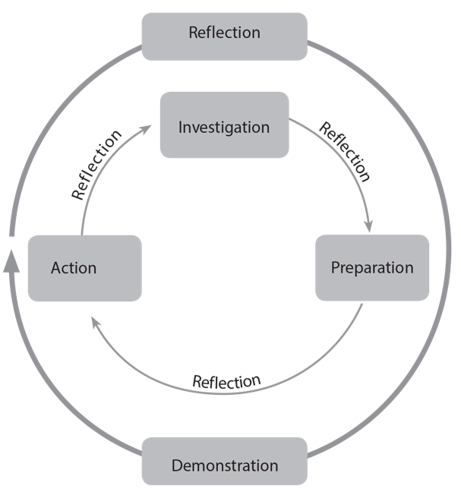

The centre circle represents the process: investigation, preparation, action and reflection. Reflection will occur intermittently in response to significant experiences.

The outer circle guides the summarisation of experiences: reflection and demonstration.

Investigation: identify interests, skills and talents to be used for experiences, as well as areas for personal growth and development. Investigate what you want to do and determine the purpose. In relation to service, identify a need you want to address.

Preparation: clarify roles and responsibilities, develop a plan, identify specified resources and timelines, and acquire any skills needed.

Action: implement the idea or plan. This often requires decision-making and problem-solving. Work individually, with partners or in groups.

Reflection: describe what happened, express your feelings, generate ideas and raise questions. Reflection can occur at any time. It can further your understanding, assist with revising plans, help with learning and make connections between growth, accomplishment and the learning outcomes. Reflection may lead to a new action.

Demonstration: make clear what and how you learned and what you have accomplished. For example, by sharing your experience in your portfolio or talking with others. Through demonstration and communication, you will enhance your understanding and evoke a response from others.

CAS STRANDS

Engagement in CAS needs to go beyond the familiar – try something new or expand on what you already know. Innovate. Grow stronger. Challenge yourself.

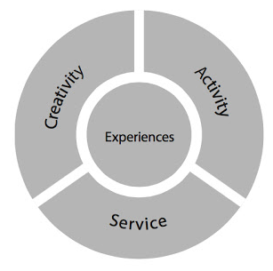

Creativity
Exploring and extending ideas leading to an original or interpretive product of performance.

Activity
Physical exertion contributing to a healthy lifestyle.

Service
Collaborative and reciprocal engagement with the community in response to an authentic need.

CREATIVITY

Creativity provides the opportunity to explore your own sense of original thinking and expression.

It can come from talents, interests, passions, emotional responses and imagination.



Ongoing creativity
If you are already involved in creativity, you can continue this. However, you need to further extend and develop your participation.
Example: You are a musician. Now, compose a song and perform it.

Individual creativity
Solitary creative experiences. Theses should take place over an extended period of time. Set goals and work towards them.
Examples: Develop a website, design some furniture or paint a series.

School-based creativity
Creative pursuits that are offered through the school.
Example: ASAs or school clubs – can you initiate a new one?

Community-based creativity
While allowing for the growth in creativity, experiences should build and sustain relationships with others. Look local first, then look wider.
Examples: Take cooking classes, contribute towards an art gallery or join a community-based theatre.

ACTIVITY

Activity aims to promote lifelong healthy habits related to physical well-being.

It may include individual and team sports, aerobic exercise, dance, outdoor recreation, fitness training and any other form of physical exertion that purposefully contributes to a healthy lifestyle.

Participation must be at an appropriate level and on a regular basis.



Ongoing activity
If you are already involved in activity, you can continue this. However, you need to further extend and develop your participation.
Example: You play basketball. Now, learn new training models or join a team.

Individual activity
Solitary creative experiences. Theses should take place over an extended period of time. Set goals and work towards them.
Examples: Attending a gym, roller-skating or swimming.

School-based activity
Creative pursuits that are offered through the school.
Example: ASAs or school clubs – can you initiate a new one?

Community-based activity
While allowing for the growth in activity, experiences should build and sustain relationships with others. Look local first, then look wider.
Examples: Join a community-based running group, dance class or aerobics class.

SERVICE

Service encourages your capacity to make meaningful contributions to your community and society.

It is one of the most transforming elements of CAS as it promotes self-awareness, offers diverse occasions for interactions and experiences and creates opportunities for international-mindedness.

Service benefits everyone involved; both you and the community, through a reciprocal collaboration.



Direct service
Interaction involving other people, the environment or animals.
Examples: One-on-one tutoring, developing a community garden or working in an animal shelter.

Indirect service
You may not see the recipients of your service but it will still benefit the community or environment.
Examples: Re-designing a non-profit website, writing picture books for someone to teach a language or nurturing seeds for a community garden.

Advocacy
Speak on behalf of a cause or concern to promote action on an issue of public interest.
Examples: An awareness campaign on hunger, performing a play on replacing bullying with respect or creating a video on sustainable water solutions.

Research
Collect information through varied sources, analyse data and report on a topic of importance to influence policy or practice.
Examples: Conduct environmental surveys to influence your school, compile effective means to reduce litter in public spaces or interview people on topics such as homelessness or unemployment.
CAS PROJECT


A CAS project is a collaborative, well-considered series of sequential CAS experiences.

It can be based on one strand or combine two or all three strands.

You must be involved in at least one CAS project during the Diploma Programme.

A minimum of one month is recommended for a CAS project, from planning to completion, but longer is encouraged.

It involves collaboration between you and other students or with members of the wider community.

Examples:

- Creativity: A student group plans, designs and creates a mural.

- Activity: Students organise and participate in a sports team including training sessions and matches against other teams.

- Service: Students set up and conduct tutoring for people in need.

- Creativity and activity: Students choreograph a routine for their marching band.

- Service and activity: Students plan and participate in the planting and maintenance of a garden with members of the local community.

- Service and creativity: Students identify that children at a local school need backpacks and subsequently design and make the backpacks out of recycled materials.

- Creativity, activity and service: Students rehearse and perform a dance production for a community retirement home.

CAS PROJECT
★Important Information You Should Know about CAS Project
A CAS Project is a “collaborative, well-considered series of sequential CAS experiences, engaging students in one or more of the CAS strands of Creativity, Activity and Service.”
Basic Requirement: | You are required to have at least one CAS project during your CAS program.
How to understand ‘Collaborative’? | You are required to work with others in the planning, delivery and evaluation of your projects. This can be with a partner or a larger group, and may involve collaborating with other students from your school or another school, or with members of the wider community.  Whatever the size of your group and where members are from, everyone should play an active role in all stages (the 5 CAS Stages) of the project. The roles that each member plays should be clearly defined in your CAS Action Plan, which is supposed to develop during the Preparation stage of your projects. Currently, in TWS, we use CAS Project Formation Form.
How to understand ‘Well-considered’? | All CAS projects should use the 5 CAS Stages as a framework, and much work is required before you can go ahead and act. Because your CAS project is expected to be a significant undertaking, the duration and complexity of the Investigation and Preparation stages are likely to be at a higher level than in a CAS experience. Planning and implementing a sustained CAS project provides opportunities to enhance and integrate your personal interests, skills and talents into your collaborative work, and to demonstrate a number of the CAS learning outcomes.
What does ‘series of sequential CAS experiences’ mean? | A CAS project can be based in any one of the three CAS strands, or be a combination of two or all three strands. It is suggested that your project take place with regular commitment over a longer period of time (longer than the suggested minimum of one month’s duration, because a project that lasts for four weeks, from the first involvement of investigation to the final demonstration, generally means that your commitment and contributions are intense, something that can be extremely stressful). In TWS, we suggest a minimum of one semester.
Difference between a CAS project and a CAS experience
Who is involved | Acting alone would mean that it is an experience. Working with others could make it into a project.
The nature of the involvement | Attendance without much influence on decision-making or the direction of the pursuit would mean that it is an experience. Being involved with others in making decisions and planning for your action/performance could mean that it is a project.
Samples of CAS experience & CAS project | Basketball:  Experience -Being a player in the school basketball team over an 8-week season.  Project -Recruit fellow students and friends to form a team to participate in a local tournament. Work together to organize weekly skill and fitness training sessions over the 12-week season.

CAS PROJECT FORMATION FORM

Project Name
Student project Organizers

Members/Participants

CAS strand(s) of this project | Creativity ( ) Activity ( ) Service ( )
Anticipated Start Date and End date of this CAS project | From __________________________ to _____________________________
Project Outline

Provide an overview of your project and list what you hope to achieve.

How we are following the CAS stages | For each CAS stage, describe either what has been done or what you plan to do.
Investigation

Preparation
Action
Reflection
Demonstration
Targeted learning outcome(s) for this project | For the learning outcomes of your choice, describe in details and list ways of present evidence (select as many as possible).
Strength & Growth
Challenge & Skills
Initiative & Planning
Commitment & Perseverance
Collaborative Skills
Global Engagement
Ethics of Choices & Actions
Is your CAS project Specific enough? Why?
Is your CAS project Measurable? Why?
Is your CAS project Attainable? Why?
Is your CAS project Relevant to your CAS program?
Is your CAS project Time-oriented?
Name of organization the project is organized with or for, if applicable
Contact person at organization, contact phone and email, if applicable
Supervisor (teacher or other external supervisor)
List the possible risks?
Project Monitoring and Evaluation

How you will monitor the progress and evaluate your achievement of the outcomes.

Student signatures
Other information

- Each DP student should submit this Project Formation Form for your CAS project. Upload this form to your CAS portfolio as evidence.
- If your CAS Project is part of the School’s ASA program, you also need to fulfill a Student-led ASA planning form and ASA session Plan (session plan can be developed later on a monthly basis).
- If you need more visualized materials to support your project proposal, you can make this form in other ways as long as you include all the items, such as PowerPoint, Video, etc.

THE CAS PORTFOLIO

Using Managebac, you are expected to maintain and complete a portfolio as evidence of your engagement with CAS (see Page 23-30: Managebac tutorial).

This will include your experiences as well as reflections and evidence of those experiences.

Your portfolio needs to be kept up to date. This means adding evidence of completion and reflections soon after it the CAS experience or project is finished.

Notes from your meetings with the CAS coordinator and/or adviser will be added to your portfolio.

While CAS is not formally graded, your final portfolio is what is submitted to the CAS Coordinator for checking, and will be a large determinant in whether you have passed CAS or not.



Experiences:

This is a chronicle of your CAS journey.

It includes a variety of reflections, learning moments, personal achievements and how you have used the CAS stages.

Add your reflections all throughout the programme.

Evidence:

Collect evidence of your involvement and achievements.

It may include planning documents, letters, emails, certificates, acknowledgements of participation and achievements, photographs, videos and so on.
REFLECTIONS

“WE DO NOT LEARN FROM EXPERIENCE…
WE LEARN FROM REFLECTING ON EXPERIENCE.”
- JOHN DEWEY

Being reflective is one attribute of the IB learner profile:

“We thoughtfully consider the world and our own ideas and experience. We work to understand our strengths and weaknesses in order to support our learning and personal development.”

UNDERSTANDING REFLECTION

Reflection is… | Reflection is not…
- Honest  - Personal  - Done in many different forms  - Sometimes difficult  - Sometimes easy  - Sometimes creative  - Building self-awareness  - Necessary for learning  - What you did, combined with how you felt  - Surprising  - Helpful for planning  - Done alone or with others  - About thoughts, feelings and ideas  - Adding perspective | - Forced  - Right or wrong  - Good or bad  - Marked or graded  - Difficult  - Copying what someone else said  - Predictable  - To be judged by others  - Only a summary of what happened  - Done to please someone else  - A waste of time  - Only written  - Only discussion  - Only led by teachers

Forms of reflection:

Reflection can appear in many forms. For example:
- Photographs
- Song
- Poetry
- Film
- Posters
- Recording of a discussion
- Theatre production

Elements of reflection:

Describe what happened – retell the memorable moments, identify what was important or influential, what went well or was difficult, obstacles and successes.

Express your feelings – outline the emotional responses to your experiences.

Generate ideas – have a deeper look at your choices and actions.


Ask questions – about people, processes or issues.

Extending reflection:

Go beyond the simple questions.

For example…
What did I do?

could become… Why did I make this particular choice?
How did this experience reflect my personal ideas and values?
How am I challenged to think differently about myself and others?

OR

How do I feel?

could become… How did I feel about the challenges?
What happened that prompted particular feelings?
What choices might have resulted in different feelings and outcomes?

Time for reflection:

Purposeful reflection is about quality not quantity.

You are not expected to reflect on every CAS experience – identify ones that are worthy.
- A moment of discovery
- A skill is mastered
- A challenge is confronted
- Emotions are provoked
- Achievement deserves celebration

Reflect at the beginning, during and the end of experiences.

DP CAS CHECKLIST: GETTING STARTED

DESCRIPTION | TICK ONLY IF YOU FULLY UNDERSTAND
I have carefully read through the information on MB about CAS and in this CAS handbook and I fully understand the CAS requirements.
I know who my CAS coordinator is and where their office is located.
I know who my CAS adviser is and where their office is located.
I know that I can always discuss CAS issues and concerns with my CAS team.
I am aware of the two-year CAS timetable and will follow it.
I will maintain a balance among Creativity, Activity and Service.
I will have every experience approved by the CAS coordinator before starting them.
I will regularly update my CAS portfolio.
I must have a responsible adult supervisor (not a family member or fellow student) for each CAS experience.
I will follow the 5 CAS stages when undertaking any experience.
I am aware that I must present evidence for meeting all seven learning outcomes in my portfolio.
I will meet all deadlines.
I clearly understand that without the satisfactory and timely completion of the CAS programme, I will not be awarded the Diploma.

SIGNATURES:

______________________ ___________ ______________________ ___________
STUDENT DATE PARENT DATE

______________________ ___________ ______________________ ___________
CAS ADVISER DATE CAS COORDINATOR DATE
DP CAS TIMELINE AND DEADLINES

GRADE | TIME | REQUIREMENTS
DP1  (G11) | August-September | - Read the CAS Student Handbook and CAS School Guide on MB carefully.  - Be familiar with the CAS routine, CAS concepts.  - Go through CAS checklist and get signatures once each item is fully understood.  - Map out your CAS programme  - Start adding experiences to your portfolio.
DP1  (G11) | October | - Have first interview with CAS coordinator and advisor  - Keep update your CAS portfolio on MB on a weekly basis.
DP1  (G11) | November-January | - Continue adding to your CAS portfolio regularly.  - Some experiences already complete including evidence, reflections and supervisor review.  - Set up informal meetings with CAS coordinator to discuss your experience so far.  - Start planning your CAS project(s).
DP1  (G11) | February-April | - Keep update your CAS portfolio on MB on a weekly basis.  - You should have 5-7 learning outcomes included in your CAS portfolio.  - Start planning some summer CAS experience/project.
DP1  (G11) | May-June | - Check your portfolio and make sure all areas are up to date.  - Complete experience/project with supervisor review.  - Have second interview with CAS coordinator and advisor.  - Work on your CAS plan for the summer vacation.
Summer Break | July-August | - Carry out your summer CAS Plan, get involved in CAS outside of the school community.  - Keep update your CAS portfolio on MB on a weekly basis.
DP2 (G12) | September-October | - Meet with CAS coordinator and advisor to reflect on your CAS progress in the summer vacation.  - Check your portfolio and make sure all areas are up to date.  - Most experiences and project(s) are complete.
DP2 (G12) | November-December | - Review evidence and reflections in your CAS portfolio on MB.  - Keep update your CAS portfolio on MB on a weekly basis.  - Ensure all learning outcomes have been achieved at least twice.
DP2 (G12) | January-April | - Have third interview with CAS coordinator and advisor.  - Complete all the CAS elements on MB as required.
DP2 (G12) | April 30th | - All CAS requirements must be completed.

NOTE: If April 30th falls on a non-school day, all CAS requirements must be complete by the following school day.

Failure to meet this deadline may result in not being awarded the IB Diploma.

GUIDELINES TO CAS EXPERIENCES

A CAS experience can be a single event or may be an extended series of events.

Questions to ask yourself:

- Will the experience be enjoyable?

- Does the experience allow for development of personal interests, skills or interests?

- What new possibilities or challenges could the experience provide?

- What might be the possible consequences of your CAS experience for you, others and the environment?

Remember:
- Plan. What? When? Where? Who? How? AND Why?

- Ask for help if you need it.

- Include CAS strands and learning outcomes.

- Vary your experiences – create a balance between creativity, activity and service.

- Keep your portfolio up to date.

- Reflect, reflect, reflect.

MANAGEBAC TUTORIAL

STEP-BY-STEP PROCESS

- Add a new experience.

- The CAS coordinator will be notified via email.

- The CAS coordinator approves the experience.

- You will be notified via email if there’s any adjustment you need to make.

- Complete the experience and add reflections.

- Supervisor receives email and completes supervisor form.

- The CAS coordinator reviews reflections and marks the experience complete.



ADDING A CAS EXPERIENCE

Go to IB Manager ➡️ CAS, then click on “Add CAS Experience” on the right-hand side of the page.


Add the necessary information.
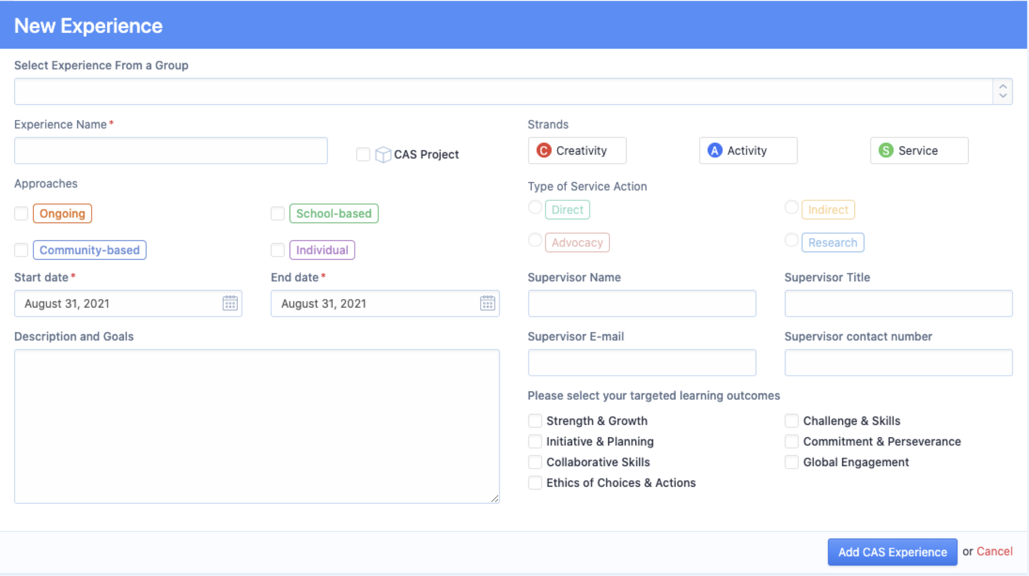

Information includes:
- Experience name (It’s not suggested that you choose from an existing group from the dropdown menu)
- Tick box if this is a CAS project
- Experience strand
- Experience approach
- Start and end dates
- Experience supervisor information (an email notification will be sent to the email address you provide, at the completion of the experience, for supervisor review).
- Tick targeted learning outcomes

Once you have completed the required information, click “Add CAS Experience”. This will automatically send an email to your CAS coordinator for approval.

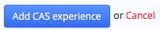

Please refer to the next page for the key steps of adding a new CAS experience on MB

Key Steps of Adding a New CAS Experience on MB
a. Finish the “New Experience” page.
b. Add When, Where, What, How and your personal goals in the “Description and Goals” section, if it’s a group activity, specify your role and duties in the group.
c. Answer the following four CAS Proposal questions and upload as your first reflection to the new CAS experience.
- Which strand/s of C, A and S will it fit? Please explain.
- Learner profile attributes that I shall be developing as a result of my participation.
- Is it part of my course for the IB Diploma Program?
- Will it be fun to do this? Why or why not?

Sample CAS Student Proposal
Which strand/s of C, A and S will it fit? Please explain. | Creativity: Because this experience will result in the production of a new product from my creative thinking and designing. This app is going to be a unique piece of work.  Service: My explanation of how the app might work will also be a service to people who want to use my app.
Learner profile attributes that I shall be developing as a result of my participation. | Inquirer: I have to find out how to encode my app and develop it.  Communicator: I am going to have to communicate with people to help develop the app and also to promote it when it is completed. In doing this I am also going to achieve the CAS Learning Outcome of collaborating with others.  Risk-taker: I am going to take on something which is brand new to me and I may risk failure.  Knowledgeable: I am going to become knowledgeable about developing apps.  Principled: I must make sure that I do not steal someone else’s idea.  Thinker: This will force me to think creatively and originally. I will have to solve several problems.
Is it part of my course for the IB Diploma Program? | No, this experience will definitely not be part of my IB Diploma Program.
Will it be fun to do this? Why or why not? | Yes, I definitely think this will be enjoyable and a real challenge for me.

ADDING REFLECTIONS AND EVIDENCE

Go to IB Manager ➡️ CAS, then choose the experience that you would like to add reflections or evidence to.

Click on the “Reflections & Evidence” tab.

Choose from Journal, File, Video, Website, Photos to “Add New Reflection & Evidence”.
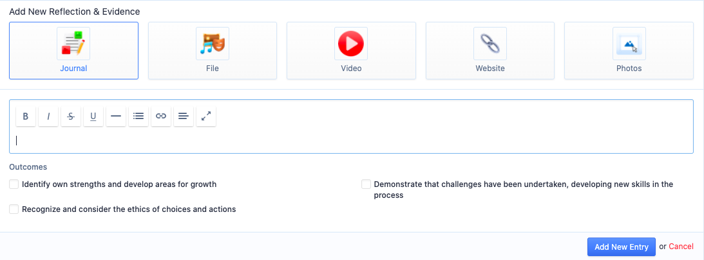

Add the necessary information. Make sure you have linked your reflections and evidence to one or more of your targeted learning outcomes – tick the box/es.
Click “Add New Entry”. 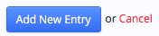

NOTE:
- It is suggested that you use Journal to upload website link by clicking the “Link” tab.
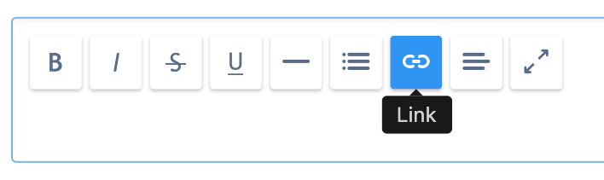
Choose “Insert Link”.
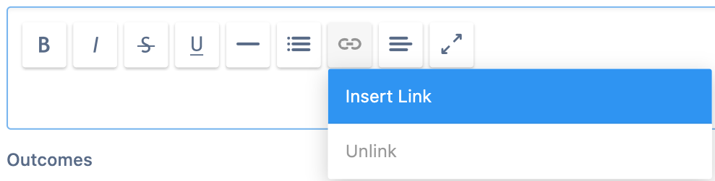
Add the weblink in the “URL”, and fill in the “Text” with name of the webpage. Click “Insert”. Then you can write in the Journal to explain the connection between this weblink and your CAS experience.
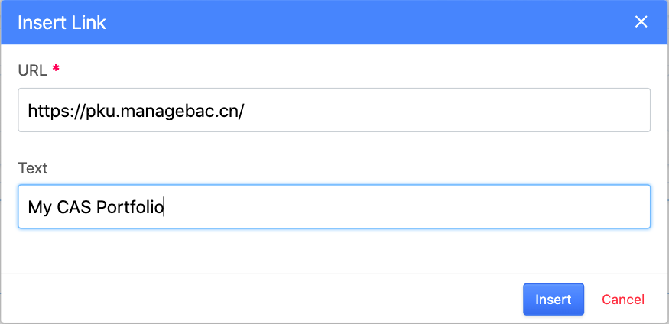

- Remember to fill in the “Caption” with a brief explanation of each photo you upload.
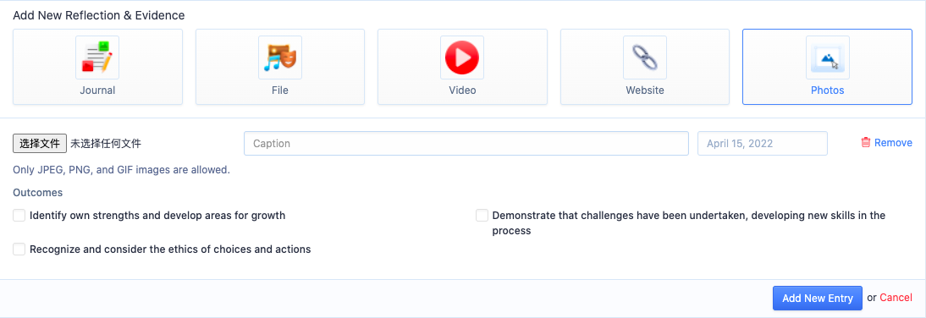

- If the default Date is not the actual date of the photo, add the actual date in the “Caption”.

- When you upload a file, please make sure you have name the file properly.
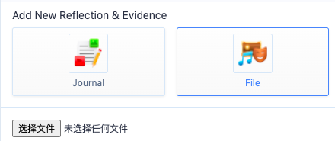

Weekly CAS Routine:
- Check each CAS experience/project’s page for messages from CAS teacher/supervisor, make adjustment ASAP and inform your CAS teacher during CAS time.
- Update each of your CAS experience/project with evidence and reflection.
- If you need CAS coordinator to change something on your CAS worksheet, please bring them up during CAS time or send an email.
- For each CAS experience:
1. Add reflection at least once every other week. (CAS Project needs to be once a week)
2. You can write one reflection in Chinese in every four reflections.
3. Evidence should be uploaded with proper name (easy for CAS teacher/supervisor to understand), Photos should have captions.

OBTAINING SUPERVISOR REVIEWS

OPTION 1: EMAIL

Go to IB Manager ➡️ CAS, click on the “Summary” tab.
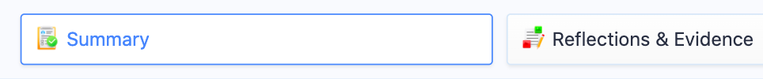

Click on “Request Supervisor Review” on the right-hand side of the page.


NOTE: ONLY click on “Request Supervisor Review” IF your experience has been approved AND you have added all of your reflections and evidence.

OPTION 2: PDF

Go to IB Manager➡️ CAS, click on the “Summary” tab. Then click on “CAS Completion Form” on the right-hand side of the page. Print and take to your supervisor for comment and signature, then give it to your CAS Coordinator.


NOTE: ONLY submit your “CAS Completion Form” IF your experience has been approved AND you have added all of your reflections and evidence.

JOINING A GROUP

Go to IB Manager

Click on “Groups” tab on the left-hand side of the page.



Click “Join More Groups…” to see a full list of already available groups.

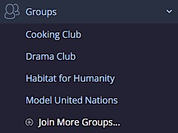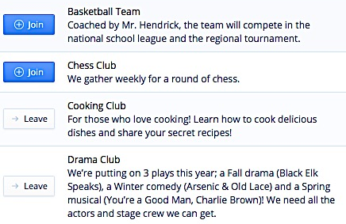

You can search for a group by name or description.

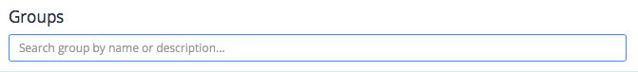

Click “Join” to join a group, or “Leave” to leave a group.



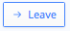

ANALYSING YOUR CAS EXPERIENCES

Go to IB Manager > CAS

You will find your CAS worksheet.



Your CAS worksheet has two tools designed to help you keep track of your experiences.

Scroll down.

OUTCOMES

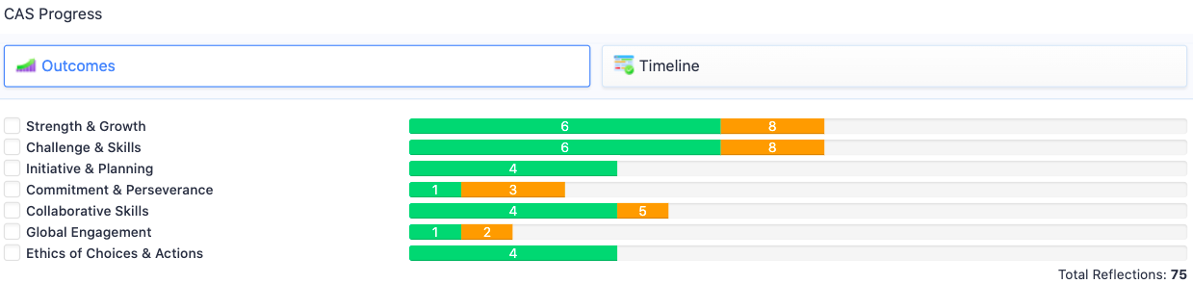

The “Outcomes” tab shows you how many times a learning outcome has been selected.

TIMELINE

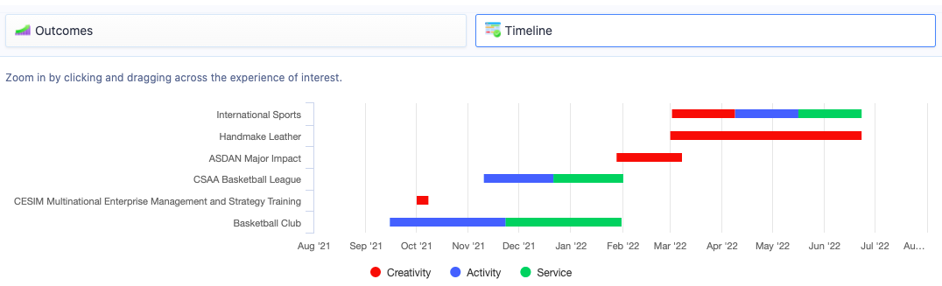

The “Timeline” tab show you the length and type of each experience.

A FINAL WORD

CAS is an individual experience designed by you, for you.

It is an excellent way for you to continue your education outside of the classroom setting and gives you the opportunity to pursue your interests and grow through experiences.

It is about being an active member of society and reaching out to your local, national and global community.

You will learn more about who you are. Enjoy it.

We are here to support you in all that you do.
If you have any questions or concerns, please do not hesitate to contact your CAS coordinator and/or adviser.

Start thinking, planning, doing and reflecting!



___________________________________________________________________________

Sources used in the creation of this document:
- IB DP Creativity, activity, service guide. For students graduating in 2017 and after.
- CAS student handbook – New Cairo British International School
- CAS student handbook – Vanguard High School
- CAS student handbook – Bali Island School

